BCSE-III Compiler Design Assignment-3
Using POSIX lex Lexical Analyzer Generator
Name: Chirantan Nath
Roll: 101910501064 (Section A3)
Session: 2024-25.

Problem 1
Write a lex file to check the validity of a binary message that starts with 1 and ends with 101 and contains any number of dots in between the parts of the messages.

lex Code:
%{
/* Write a lex file to check the validity of a binary message that starts with 1
and ends with 101 and contains any number of dots in between the parts of the messages. */
%}
%%

1\.*101\n {puts("String follows pattern.");}

[Ee][Xx][Ii][Tt]\n {return 0;}

.+\n {puts("String does not follow pattern.");}

%%
inline int yywrap() {return 1;}

int main() {
puts("Enter strings to be checked in each line. Enter EOF or \'exit\' to exit.");
yylex();
}

Output:
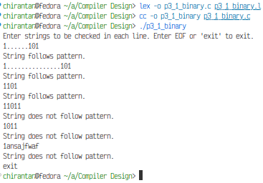

(continued on next page)

Problem 2
Write a lex program to recognize a string that starts with a capital letter which is followed by any small letter or decimal digits and ends with a special character of your choice.

lex Code:
%{
/*
Write a lex program to recognize a string that starts with a capital letter
which is followed by any small letter or decimal digits and ends with a special
character of your choice.
*/
%}
exit [Ee][Xx][Ii][Tt]
LETTER [A-Z]
letter [a-z]
digit [0-9]
special \$
%%
{LETTER}({letter}|{digit})*{special}\n {puts("String given follows pattern.");}
{exit}\n {return 0;}
.+\n {puts("String given does not follow pattern.");}
%%
inline int yywrap() {return 1;}
int main() {
puts("Enter strings to be checked in each line. Enter EOF or \'exit\' to exit.");
yylex();
}

Output:
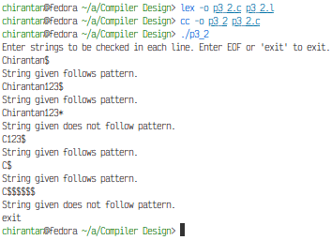

(continued on next page)

Problem 3
Write a lex program that will function as a calculator and perform the operations like addition, subtraction, multiplication, division, modulo and power.

lex Code:
%{
/*Write a lex program that will function as a calculator and perform the
operations like addition, subtraction, multiplication, division, modulo and power.*/
#include <stdbool.h>
enum Operation {
PLUS, MINUS, MUL, DIV, MOD, POW
} op = PLUS;
int accumulator = 0;
bool canTerminate = false;
void reset() {
op = PLUS; accumulator = 0;
canTerminate = false;
}
int intpow(int x, int n) {
int y;
if(!n) return 1;
y = 1;
while(n > 1) {
if(n & 1) {
y *= x;
n--;
}
x *= x;
n >>= 1;
}
return x*y;
}
%}
digitstart [1-9]
digit [0-9]
plus \+
minus \-
mul \*
div \/
mod \%
pow \^
whitespace [ \t\f]
%%

{whitespace}+ {/*Ignore.*/}

{digitstart}{digit}* {
int result = atoi(yytext);
switch(op) {
case PLUS:
accumulator += result;
break;
case MINUS:
accumulator -= result;
break;
case MUL:
accumulator *= result;
break;
case DIV:
accumulator /= result;
break;
case MOD:
accumulator %= result;
break;
case POW:
accumulator = intpow(accumulator, result);
break;
}
canTerminate = true;
//printf("Recognized number %d, accumulator %d\n", result, accumulator);
}

{plus} {op = PLUS; canTerminate = false;}
{minus} {op = MINUS; canTerminate = false;}
{mul} {op = MUL; canTerminate = false;}
{div} {op = DIV; canTerminate = false;}
{mod} {op = MOD; canTerminate = false;}
{pow} {op = POW; canTerminate = false;}

\n {
//puts("Calculating...");
if(!canTerminate) {
fputs("Illegal expression.\n", stderr);
} else {
printf("%d\n", accumulator);
}
reset();
}

. {
int ch;
fputs("Illegal character entered. Ignoring line.\n", stderr);
while((ch = input()) != '\n' && ch != EOF);
reset();
}
%%
inline int yywrap() {return 1;}
int main() {
puts("Enter expression on each line. Enter EOF to exit.");
yylex();
}

Output:
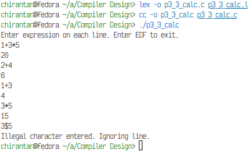

The special character we chose was the dollar sign (‘$’).

